Dear Archway Cicero Families,
Welcome to the 2017-2018 academic year of Archway Cicero! In the interest of ensuring that all practical matters are in order as we shift into the 4th year of our school, please review this packet and familiarize yourself with the information herein. If you have any questions, don’t hesitate to contact us. We are here to help.
- Informational language & Vendor Options

- School Calendar – see website

- Edukit - We highly suggest that each family take advantage of this bulk school supply program. Early bird ordering until June 10th/Final orders due July 15th. Itemized lists can be found on their website - www.edukitinc.com No purchase can be made through Edukit after July 15th.

- Consumable Book List
Please order appropriate consumables, Singapore and classroom supplies for your student’s grade level. (Student is in 1st grade so I will order 1st grade level Singapore Math workbooks.)

- Uniform Policy (Vendor Information: Dennis Uniforms)
- Traffic Flow Map

- Lunch Ordering Information to come

If you have any questions, please let us know.

Best,
Archway Classical Academy | CICERO
Administration

Literature Consumables:
Your child’s class will utilize classic works of literature during the upcoming school year. At Great Hearts Academies, it has always been the tradition for students to develop a personal library of books that they mark in, keep and return to during their time at Great Hearts, and treasure for years to come. We call these books “Classics to Keep”. Your child’s class will utilize these classics during the upcoming school year. Parents and students are strongly encouraged to purchase these books for their own personal collections, so that they can mark them and keep them, allowing students to develop their own impressive personal library of classics over the course of their academic career with Great Hearts. For families who do not purchase the texts, their student will be given access to a copy of these books as part of their curriculum. Student should not mark in these books provided by Great Hearts, and will be asked to return the books in good condition once their class has finished working with the book.
Textbook Consumables:
Archway Cicero will be providing students with Singapore Textbooks again this year. This decreases the financial burden of cost for consumables. Singapore Workbooks are the only math consumables that need to be purchased. Please see Singapore purchasing information in this packet to order the appropriate Singapore Workbooks for your student’s grade level. There will not be an opportunity to purchase these books at the school.
Alternate vendors:
Families may purchase books and other school supplies from whichever vendor they choose. We only ask that all books match the ISBN’s listed on our website. This ensures that students can all follow along on the same page when reading and discussing in class.
Uniforms:
Archway Cicero is proud to partner with Dennis Uniforms. See attached Uniform Policy.
We ask that families purchase all uniform items from Anton and Dennis Uniforms in order to ensure that the color and fit matches throughout our student body.
If the cost of the uniform presents a financial hardship for your family, please contact us for assistance.

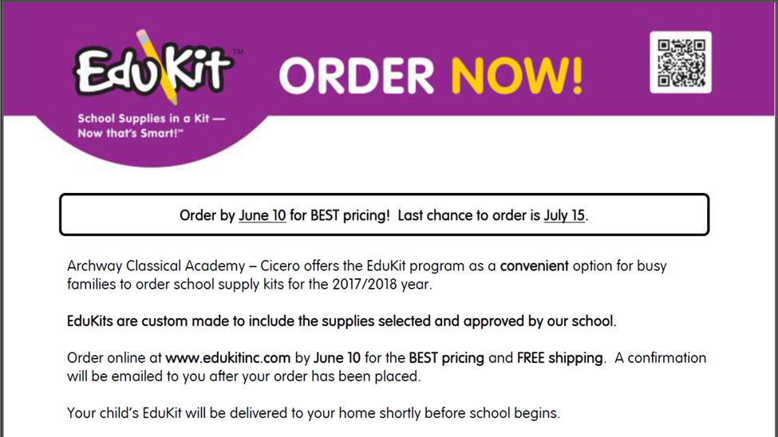
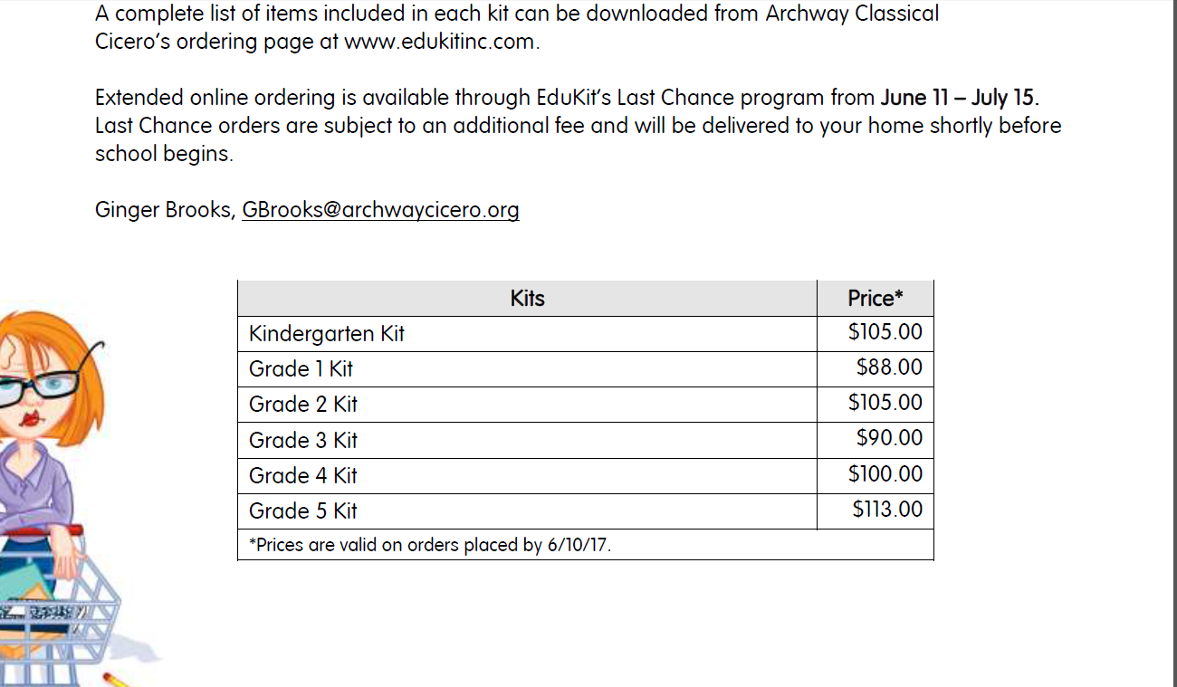

Kinder | Title | ISBN
Literature | Mr. Popper's Penguins | 9780316058438
Literature | Mike Mulligan & His Steam Shovel | 9780395259399
Literature | Velveteen Rabbit- Margery Williams (read aloud) | 9780380002559
Literature | Little Bear Box Set | 9780064441971
Literature | Mouse Soup | 9780064440417
Literature | Mouse Tales | 9780064440134
Poetry | The Harp and Laurel Wreath | 9781586176914
Writing | Spalding Spelling/Vocabulary Notebook, 5/8 Pink - NB1 | Control - click here to order
Writing | Phonogram Cards - Individual Size set of 87
Writing | Spalding Paper - Vertical Format 100 Sheets 5/8 - PA1
Math | Earlybird Kindergarten CC ED Textbook A | Control - Click here to order
Math | Earlybird Kindergarten CC ED Textbook B
1st Grade | Book Title | ISBN
Literature | The Frog and Toad Collection | 9780060580865
Literature | Planet Earth/Inside Out | 9780688158491
Literature | Sam the Minuteman | 9780064441070
Literature | Owl at Home | 9780064440349
Literature | A Bargain for Frances | 9780064440011
Literature | My Father's Dragon (optional: will be read aloud in class) | 9781453782057
Poetry | The Harp and Laurel Wreath | 9781586176914
Writing | Spalding Spelling/Vocabulary Notebook, 5/8 Pink - NB1 | Control - Click here to order
Writing | Spalding paper - vertical format 100 sheets 5/8
Writing | Phonogram Cards - Individual Size set of 87
Math | Primary Mathematics CC Ed Workbook 1A, PMCCW1A | Control - Click here to order
Math | Primary Mathematics CC Ed Workbook 1B, PMCCW1A
2nd Grade | Book Title | ISBN
Literature | Little House in the Big Woods | 9780060581800
Literature | Charlottes Web | 9780064400558
Literature | Boxcar Children | 9780807508527
Literature | Sarah, Plain and Tall | 9780064402057
Literature | The Cricket in Times Square | 9780312380038
Poetry | The Harp and Laurel Wreath | 9781586176914
Writing | Spalding Spelling/Vocabulary Notebook, 5/8 Pink - NB1 | Control - Click here to order
Writing | Spalding paper - vertical format 100 sheets 5/8
Writing | Phonogram Cards - Individual Size set of 87
Math | Primary Mathematics CC Ed Workbook 2A, PMCCW2A | Control - Click here to order
Math | Primary Mathematics CC Ed Workbook 2B, PMCCW2B

3rd Grade | Book Title | ISBN
Literature | Alice In Wonderland | 9780553213454
Literature | Pinocchio (Puffin Classics) | 9781463714413
Literature | Little House on the Prairie | 9780064400022
Literature | The Lion, the Witch and the Wardrobe | 9780064471046
Literature | The Little Prince | 9780547978840
Literature | The Trumpet Swan | 9780064408677
Literature | The Real Thief | 9780312371456
Poetry | The Harp and Laurel Wreath | 9781586176914
Writing | Spalding Spelling/Vocabulary Notebook, 3/8 Blue - NB2 | Control - Click here to order
Writing | Phonogram Cards - Individual Size set of 87
Math | Primary Mathematics CC Ed Workbook 3A, PMCCW3A | Control - Click here to order
Math | Primary Mathematics CC Ed Workbook 3B, PMCCW3B
4th Grade | Book Title | ISBN
Literature | Greek Myths | 9780440406945
Literature | Prince Caspian | 9780064409445
Literature | Robin Hood -Yesterday's Classics | 9780141329383
Literature | The Princess and the Goblin | 9780141332482
Literature | The Wizard of Oz | 9781593082215
Literature | Treasure Island | 9789176372418
Literature | Carry On, Mr. Bowditch | 9780618250745
Poetry | The Harp and Laurel Wreath | 9781586176914
Writing | Spalding Spelling/Vocabulary Notebook, 3/8 Blue - NB2 | Control - Click here to order
Writing | Phonogram Cards - Individual Size set of 87
Math | Primary Mathematics CC Ed Workbook 4A, PMCCW4A | Control - click here to order
Math | Primary Mathematics CC Ed Workbook 4B, PMCCW4B
5th Grade | Book Title | ISBN
Literature | Where the Red Fern Grows | 9780440412670
Literature | A Wrinkle in Time | 9780312367541
Literature | The Secret Garden | 9780064401883
Literature | Sherlock Homes | 9781890517083
Literature | The Tale of Troy | 9780141341965
Literature | Across Five Aprils | 9780425182789
Literature | The Voyage of the Dawn Treader | 9780064471077
Literature | Phantom Tollbooth | 9780394820378
Reference | The Merriam-Webster Dictionary | 9780877799306
Poetry | The Harp and Laurel Wreath | 9781586176914
Spanish | Spanish/English Dictionary | 9780877795193
Writing | Spalding Spelling/Vocabulary Notebook, 3/8 Blue - NB2 | Control - Click here to order
Writing | Phonogram Cards - Individual Size set of 87 - PC2
Math | Primary Mathematics CC Ed Workbook 5A, PMCCW5A | Control - Click here to order
Math | Primary Mathematics CC Ed Workbook 5B, PMCCW5B

Uniform and Dress Code
ACA has a primary objective of developing a "community of learners," dedicated to the highest standards of academics and deportment. As such, a distinctive uniform is a unifying factor within our school community. It is also a visible signature of our school to the larger community, an indicator of our unity and of our pride of purpose. This is one of the most important functions of a uniform: it identifies its wearer as part of a distinctive group with a distinctive purpose. It is a reminder to its wearer of that purpose and of one’s responsibility to that group.
The uniform is the basis of a dress code with a "professional," business‐like standard. Our students should dress their best, look their best, and do their best. All clothing must be clean, neat, reasonably pressed, and in properly fitting condition. If a child is deemed to be wearing inappropriate attire, the parent will be notified and a change of clothing may be required for attendance that day. If in doubt about the appropriateness of an article of clothing, check with the school office before purchasing. Good judgment exercised at home will be a learning activity for the child that will help to avoid embarrassment or wasted time at school. Decisions about the appropriateness of apparel may be referred to the Headmaster, whose judgment will be final. The Headmaster may make specific exceptions to the dress code, as demanded by particular religious customs.
If a student insists on rebelling by trying to beat the dress code, it will quickly become obvious to the faculty and Headmaster. Our desire is not to squash students' individuality, but to secure their commitment to a community of learners whose purpose, while at school, is not faddish coolness, or outlandishness, but scholarship and character development. We ask not only for the student's commitment to this concept, but for the parent's as well. The uniform and dress code of ACA support and reinforce our academic goals. The uniform assists us in staying focused on the true individuality offered by healthy dialogue and the development of the life of the mind for each student.
Other than the dress code requirements for school, there are special requirements for periodic, special events throughout the year, such as the “semi‐formal” dress code for concert participation and the all‐school awards ceremony. Please see Semi‐Formal Event Dress Code for an exact definition of how the Academy defines “semi‐formal” attire.
Students must stay in uniform whenever they are on campus (including the parking lot) during a school day. This means arriving on campus fully in uniform and leaving campus fully in uniform (correct shoes, shirts tucked in, etc.). Students may only change out of uniform after school with teacher/coach permission to participate in an approved curricular or extracurricular activity that requires an immediate change in dress.
Student Uniforms (Required):
1. Polo Shirt‐Short or Long sleeve with school logo
a. Color: White or Light Blue
b. Fit: Shirt must always remain tucked in
c. Vendor: Dennis Uniforms for all white or light blue shirts.
2. Pants ‐ Girls and Boys
a. Color: Navy Blue
b. Style: Flat front dress pants, no pleats, no jeans or cargo pants, with belt loops and a solid, dark belt
c. Fit: Pants should reach the shoe but not drag on the ground. No excessively baggy or tight‐fitting pants will be permitted. Pants should be worn at the waist with no undergarments visible. The slacks should have belt loops and a solid, dark belt should be used.
d. Vendor: Any as long as pants are indistinguishable from the Dennis Uniform pants
3. Plaid Jumper and/or Skort ‐ K‐2 Girls
a. Color: Navy Blue
b. Length: The skirt hem may be no higher than just above the knee, both in front and in back. Skirt hem should be within two inches of the ground when properly adjusted at the waist and kneeling on a level surface, and may be longer if desired. Skirts must be worn at the waist.
c. Dark spandex tight‐fitting shorts must be worn under the jumper
d. Vendor: Dennis Uniforms
4. Skort and/or Skirt ‐ 3‐5 Grade Girls
a. Color: Navy Blue
b. Length: The skirt hem may be no higher than just above the knee, both in front and in back. Skirt hem should be within two inches of the ground when properly adjusted at the waist and kneeling on a level surface, and may be longer if desired. Skirts must be worn at the waist.
c. Dark spandex tight‐fitting shorts must be worn under the skirt
d. Vendor: Dennis Uniforms
5. Shoes
a. Color: The shoes should be predominately white.
b. Style: Athletic (tennis, Keds) shoes
6. Socks
a. Color: White or white with school color plaid
b. Length: Ankle or knee‐high
c. Girls may also wear navy blue tights
Student Uniforms (Optional):
1. Shorts ‐ Girls and Boys
a. Color: Navy Blue
b. Style: Flat or pleated front walking shorts. Shorts should fall mid‐thigh and not be longer than the knee, with belt loops and a solid dark belt
c. Fit: No excessively‐baggy or tight‐fitting shorts will be permitted. Shorts should be worn at the waist with no undergarments visible. The shorts should have belt loops and a solid, dark belt should be used
d. Vendor: Any as long as the shorts are indistinguishable from the Dennis Uniform shorts
2. Sweater
a. Color: Navy blue with school logo
b. Style: Vest, sweater, or cardigan (no hoods)
c. Vendor: Dennis Uniforms or PSO Spirit Wear

3. Outerwear
Jackets may be worn to school for warmth but must be free of logos and messages. Jackets may only be worn before and after school and during recess.
If the cost of the uniform presents a financial hardship for your family, please contact the school office for assistance.
Hair, Jewelry and Makeup
Girls: Hair should be neatly combed or styled. Neat small bows, barrettes, headbands, and "scrunchies" are permissible as long as they coordinate with the uniform. Hair should not be arranged or colored so as to draw undue attention to the student. Hair must be natural looking and conservative in its color (no bleaching or unnatural streaking/highlighting, no deep/bright reds or oranges, no artificial jet‐black coloring, and no unnatural colors).
Boys: Hair should be neatly combed or styled. Hair must be well‐off the top of the shirt collar. Hair should not fall below the eyebrows or past the mid‐point of the ear. Hair cannot be tucked behind the ears. No shaved heads, Mohawks, rat’s tails, pony tails, or braids. Hair must be natural looking and conservative in its color (no bleaching or unnatural streaking/highlighting, no deep/bright reds or oranges, no artificial jet‐black coloring, and no unnatural colors).
Jewelry: Girls may wear small studded earrings. No loops or dangling earrings are permitted. Boys may not wear earrings. No other body piercings are permitted. Boys and girls are permitted to wear one watch. Bracelets, rings, and necklaces are not permitted unless for religious reasons.
Makeup: Students may not wear makeup of any kind.
Backpacks: Students may bring backpacks and lunchboxes to and from school. These items must be stored on the designated shelving units in the classroom during the school day. Due to small storage spaces, rolling backpacks are not permitted without a doctor’s note. Backpacks and lunchboxes should be free of icons of pop culture (peace signs, cartoon characters, team logos, tie‐dyed patterns etc.) as well as messages that are offensive or inappropriate to the academy environment.
ACA officials may search and seize property when there is reason to believe that some material or matter is present that is detrimental to the health, safety, or welfare of students.
Additional Guidelines
Hats and sunglasses may only be worn outside and must be removed when the student enters the building. Student’s skin should be free of any painted or ink drawings of any kind. Students should not draw on themselves or on others.

